**REST REQUEST**

1. Query the web service (http://host:port/sqlrest/)

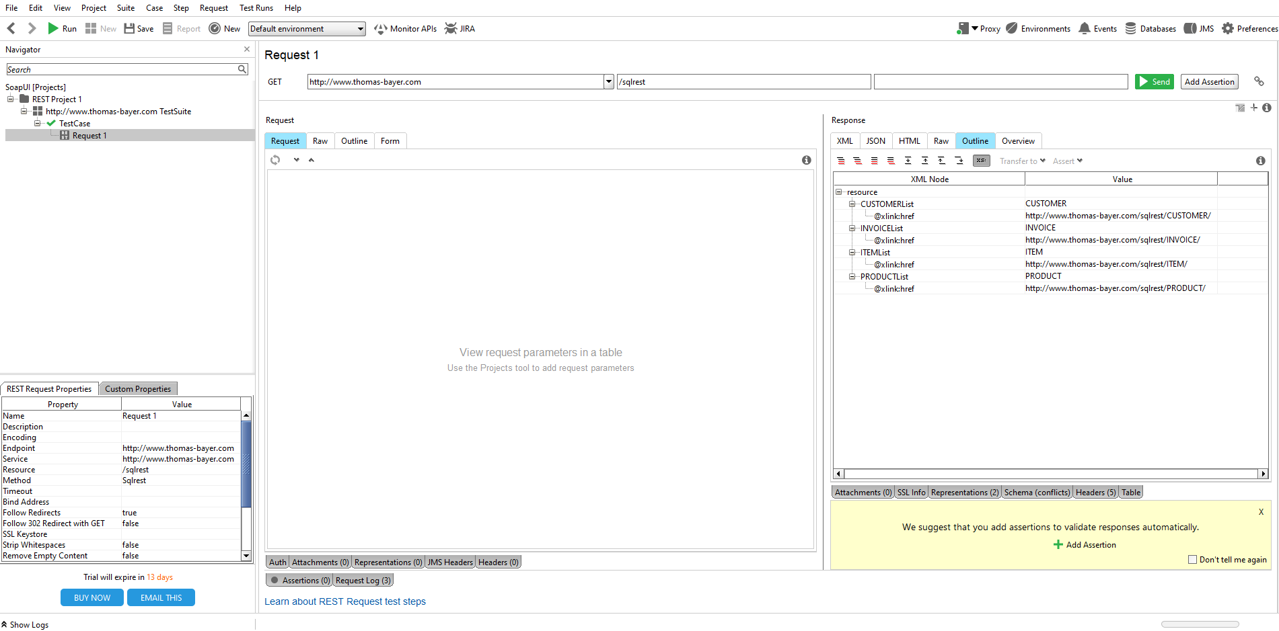

2.1. Request a list of invoices

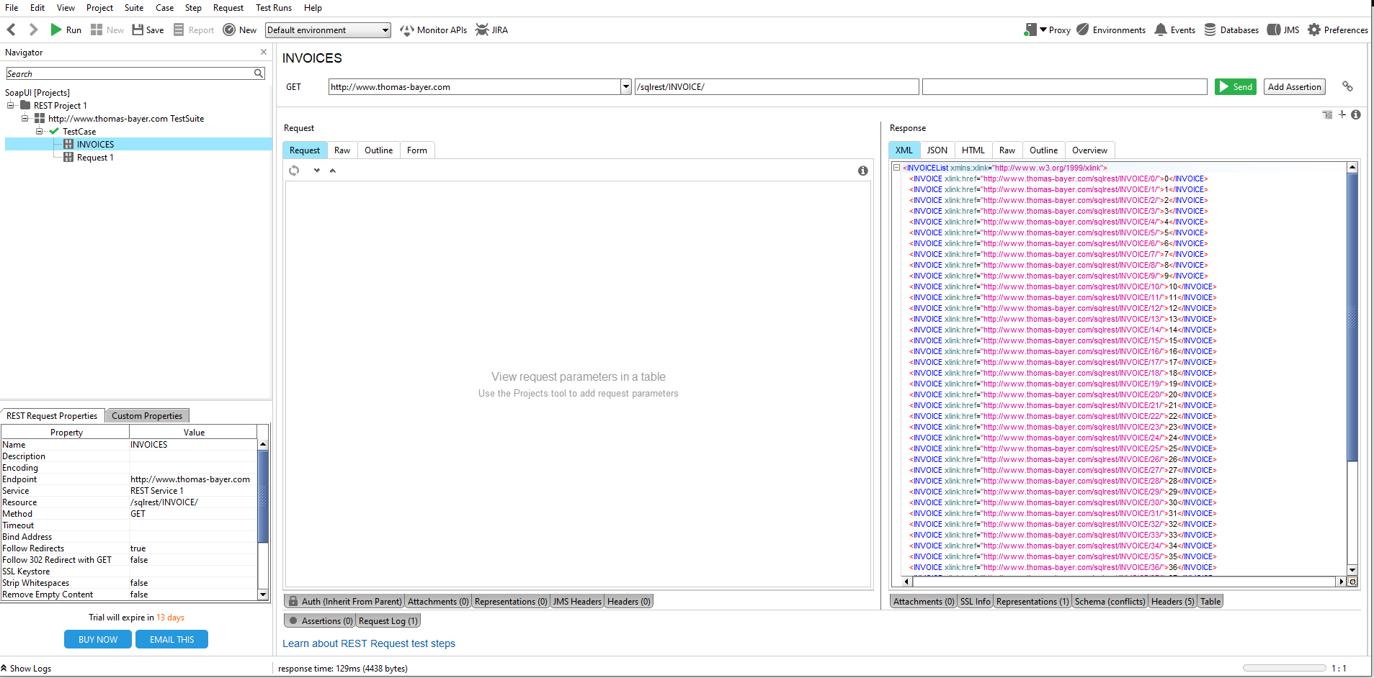

2.2. Create 3 assertions for INVOICE page

* Check that the server returns "200 OK"

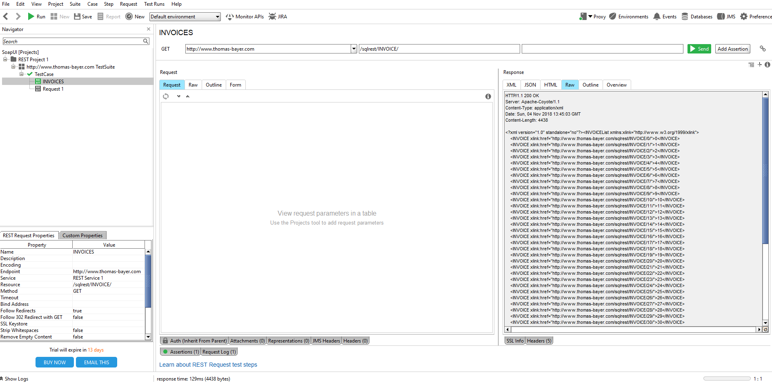

* Check that the server returns a valid pair field - the value for the page "thomas-bayer.com/sqlrest/INVOICE/2"

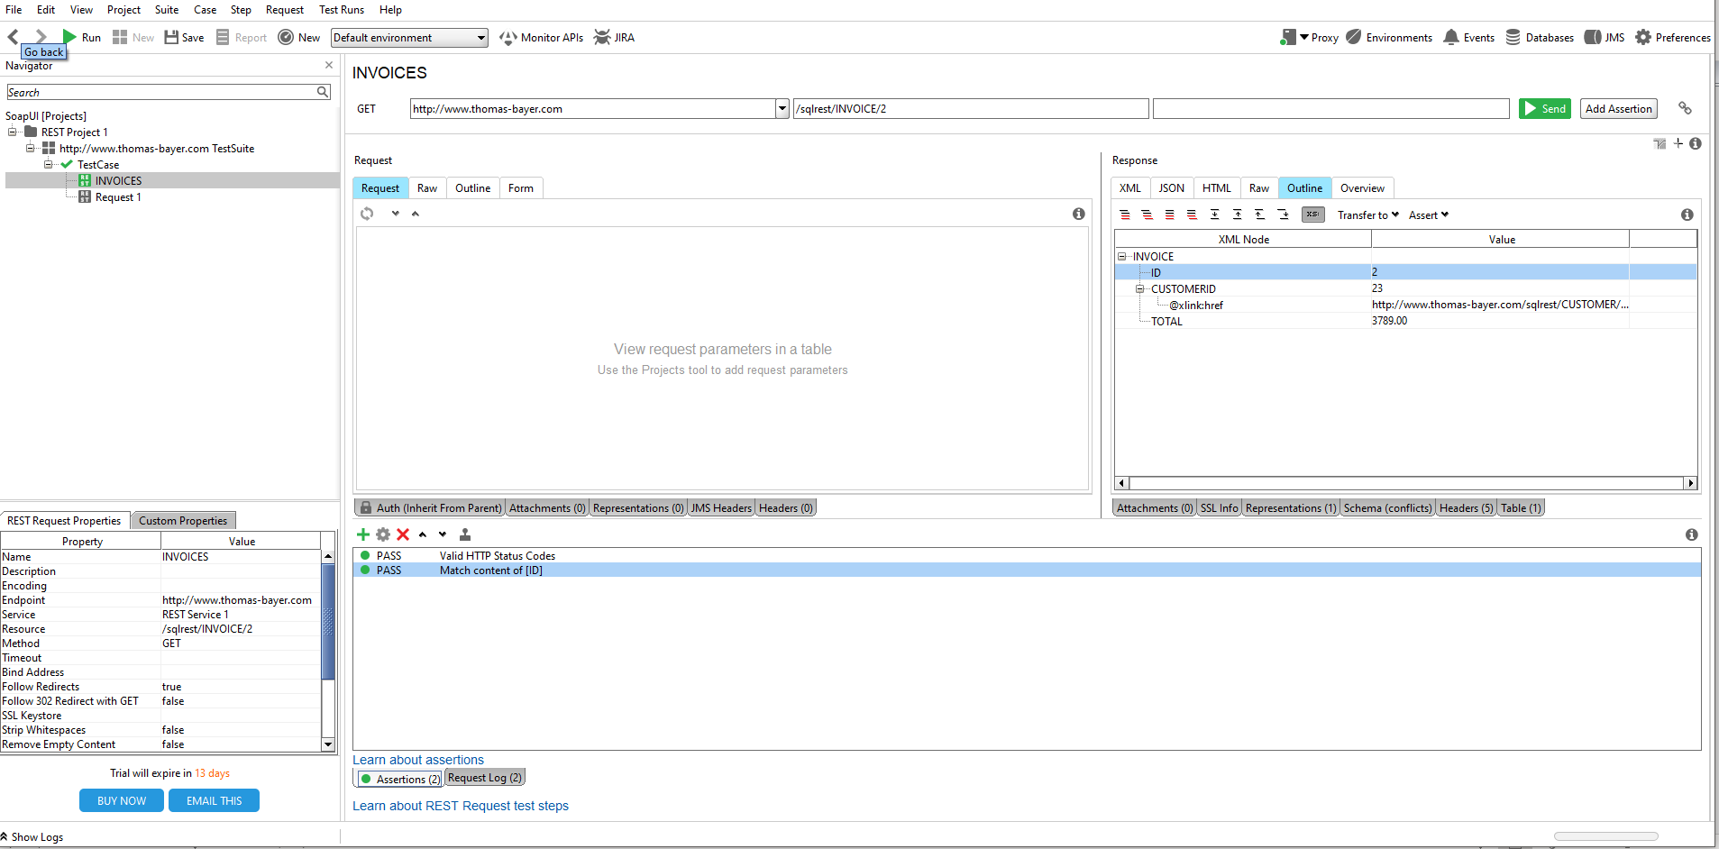

* Checks that the last received message does not expose sensitive information about the target system.

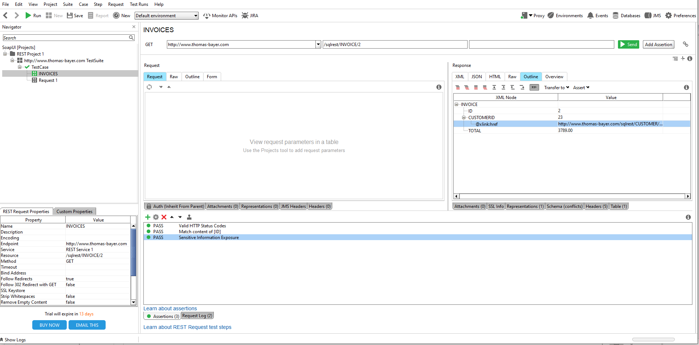

3.1 Check that the details of the invoice contains an id, a total amount and an id of the customer the invoice belongs to. The element CUSTOMERID has an XLink reference to the refered customer.

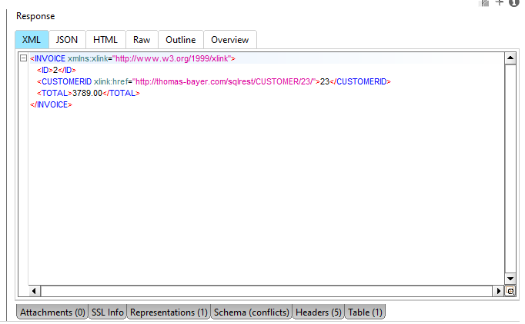

3.2 Create 3 assertions for CUSTOMER page

* Check that the page should contains "ID" field

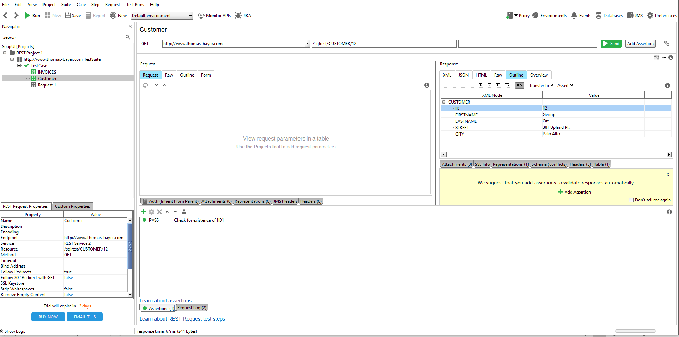

* Check that the page should contains "FIRSTNAME" field

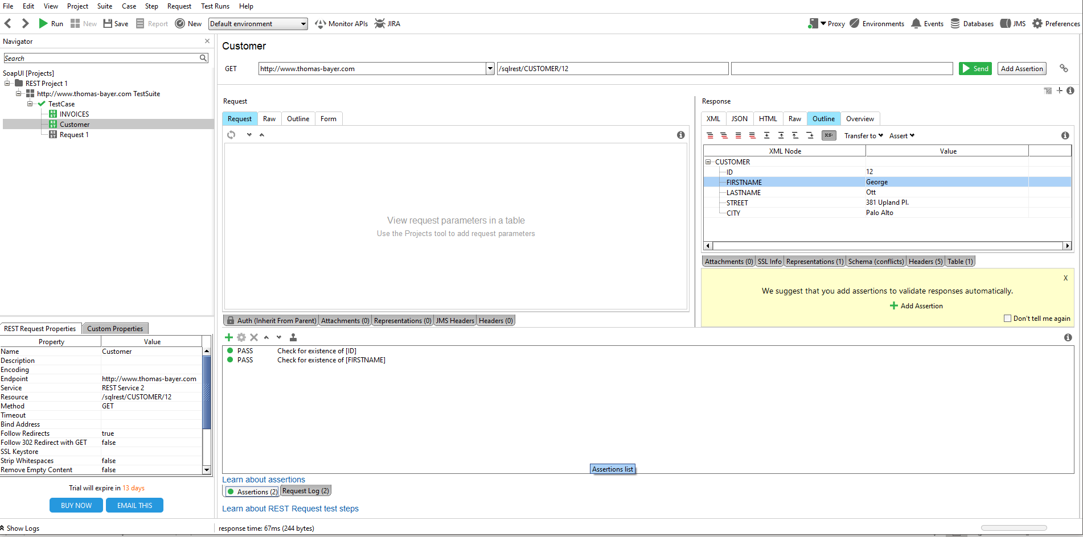

* Check that the server returns "200 OK"

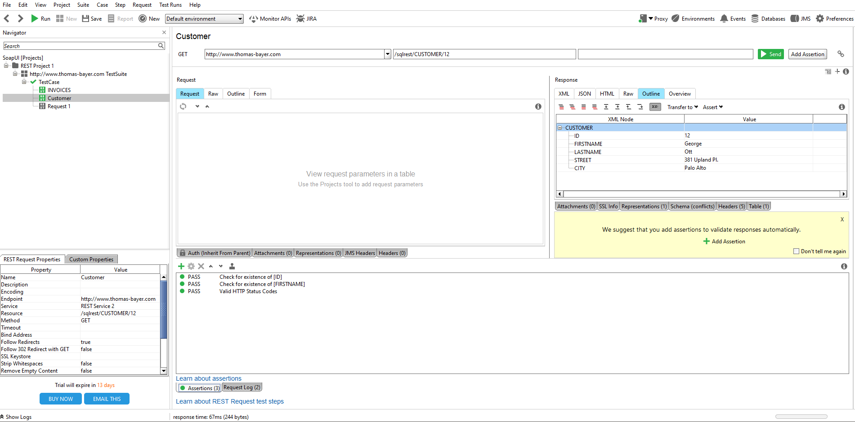

4.1 DELETE request for CUSTOMER page

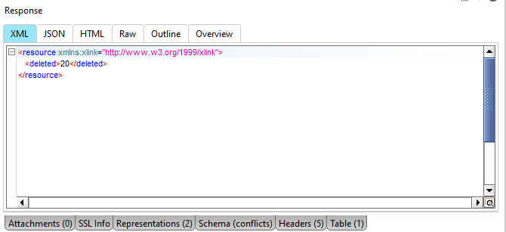

4.2 Create 3 assertions for deleted CUSTOMER page

* Check that the server returns "200 OK" when requesting a deletion

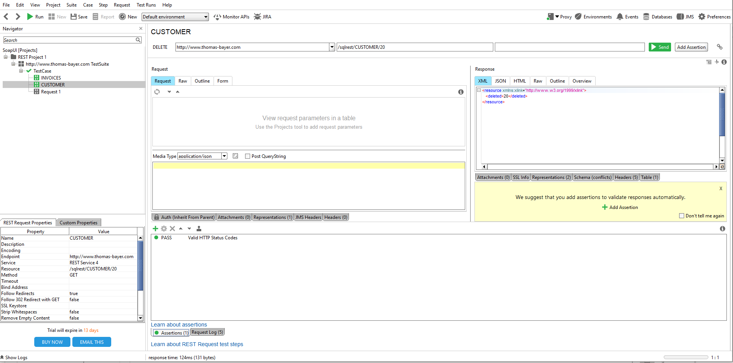

* Check that the server returns "404 Not found" after the page has been deleted

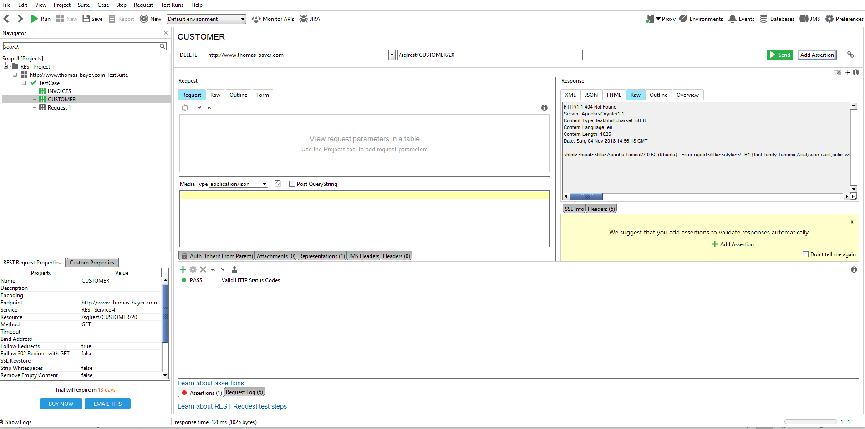

* Check that the remote page displays "404 - Resource not found"

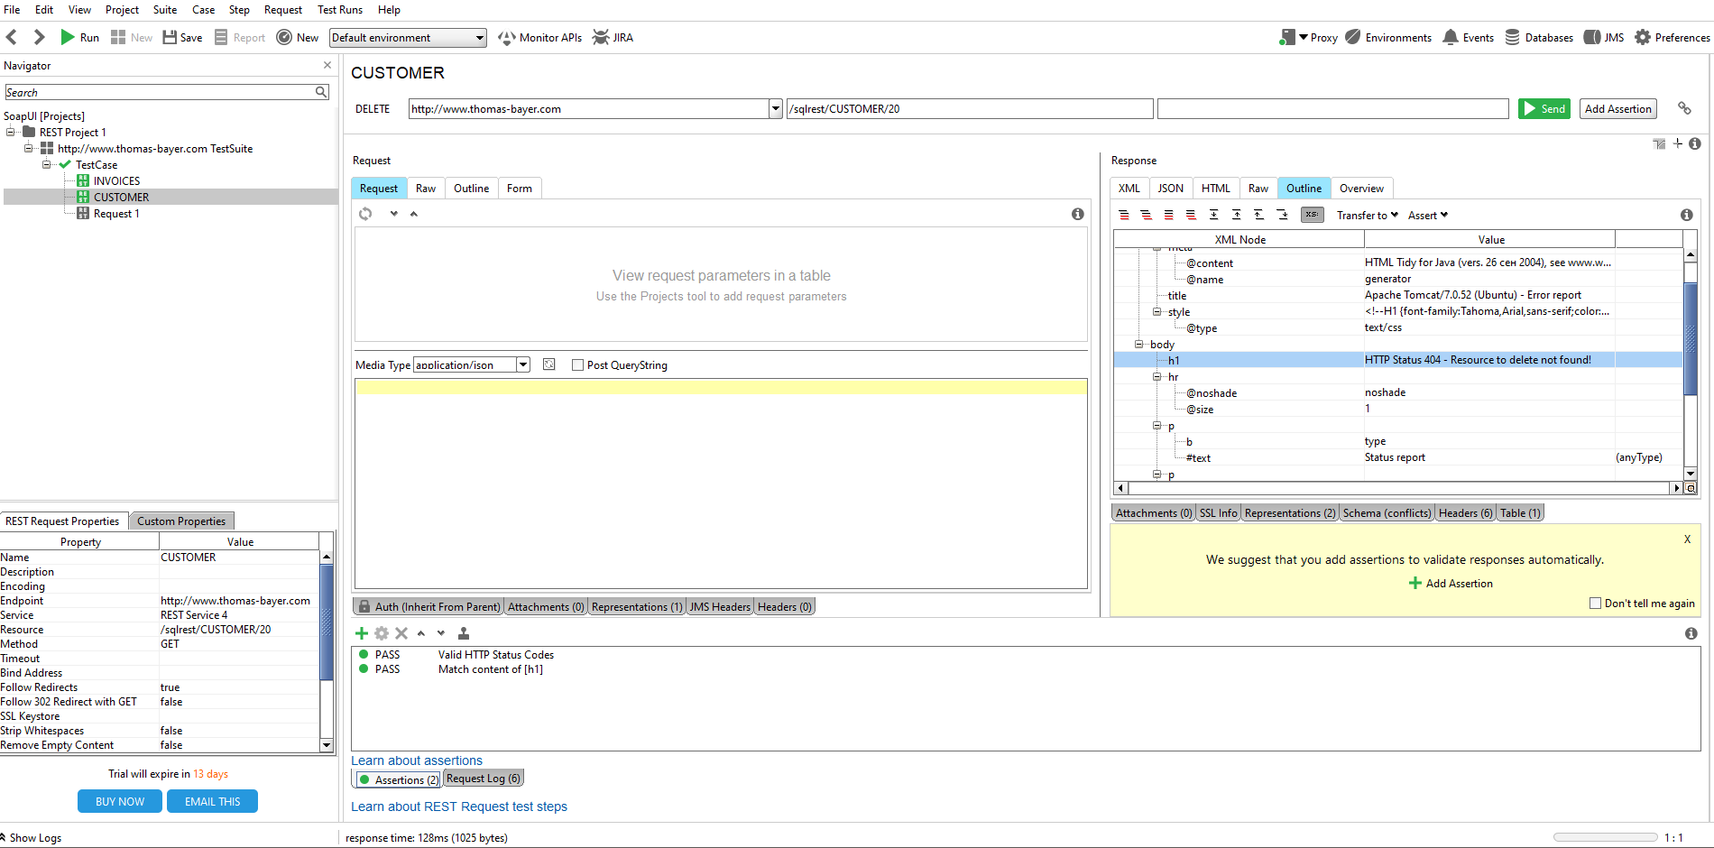

5.1 POST request for PRODUCT page

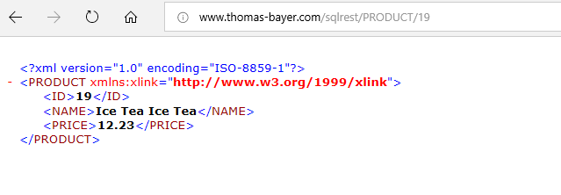

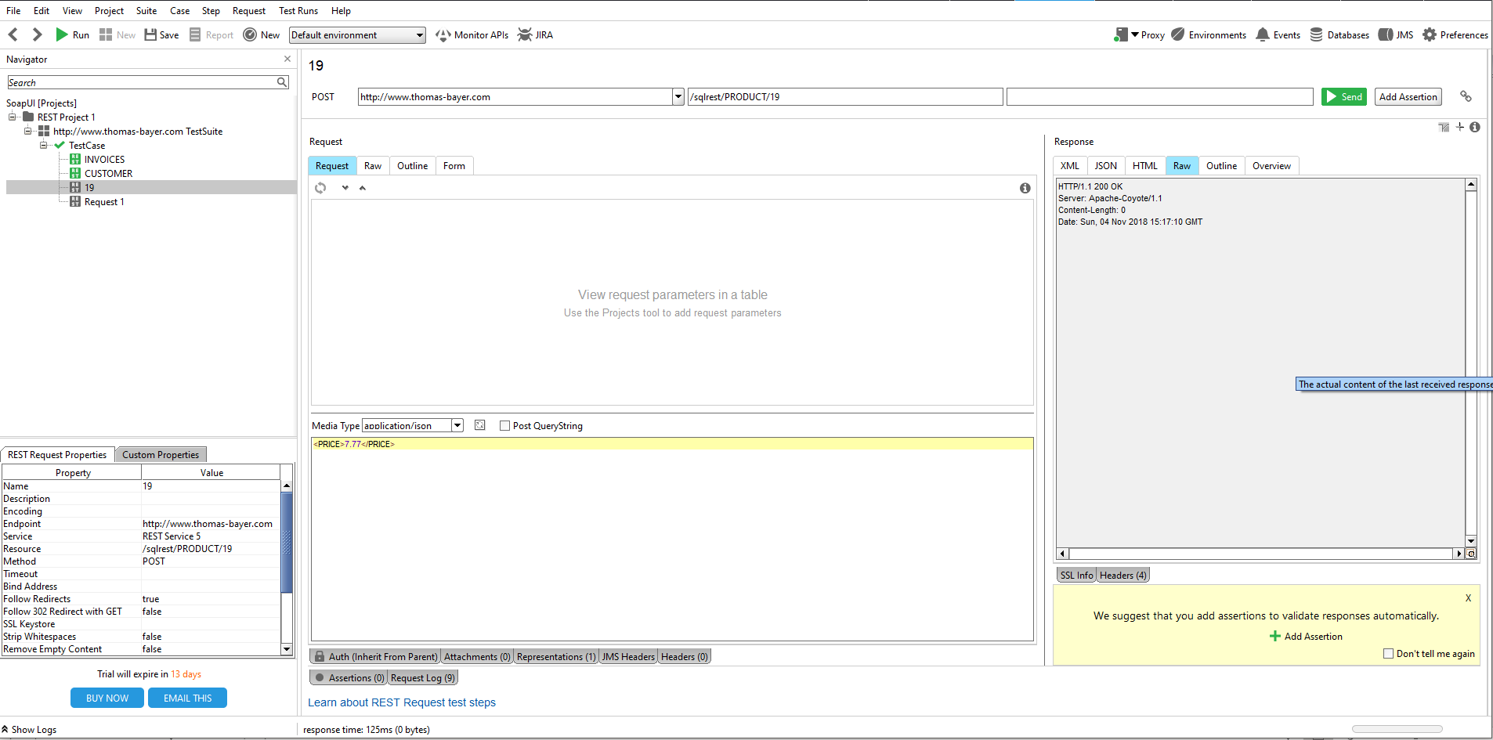

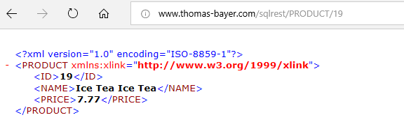

5.2 Create 3 assertions for PRODUCT page

* Check that the price is updated

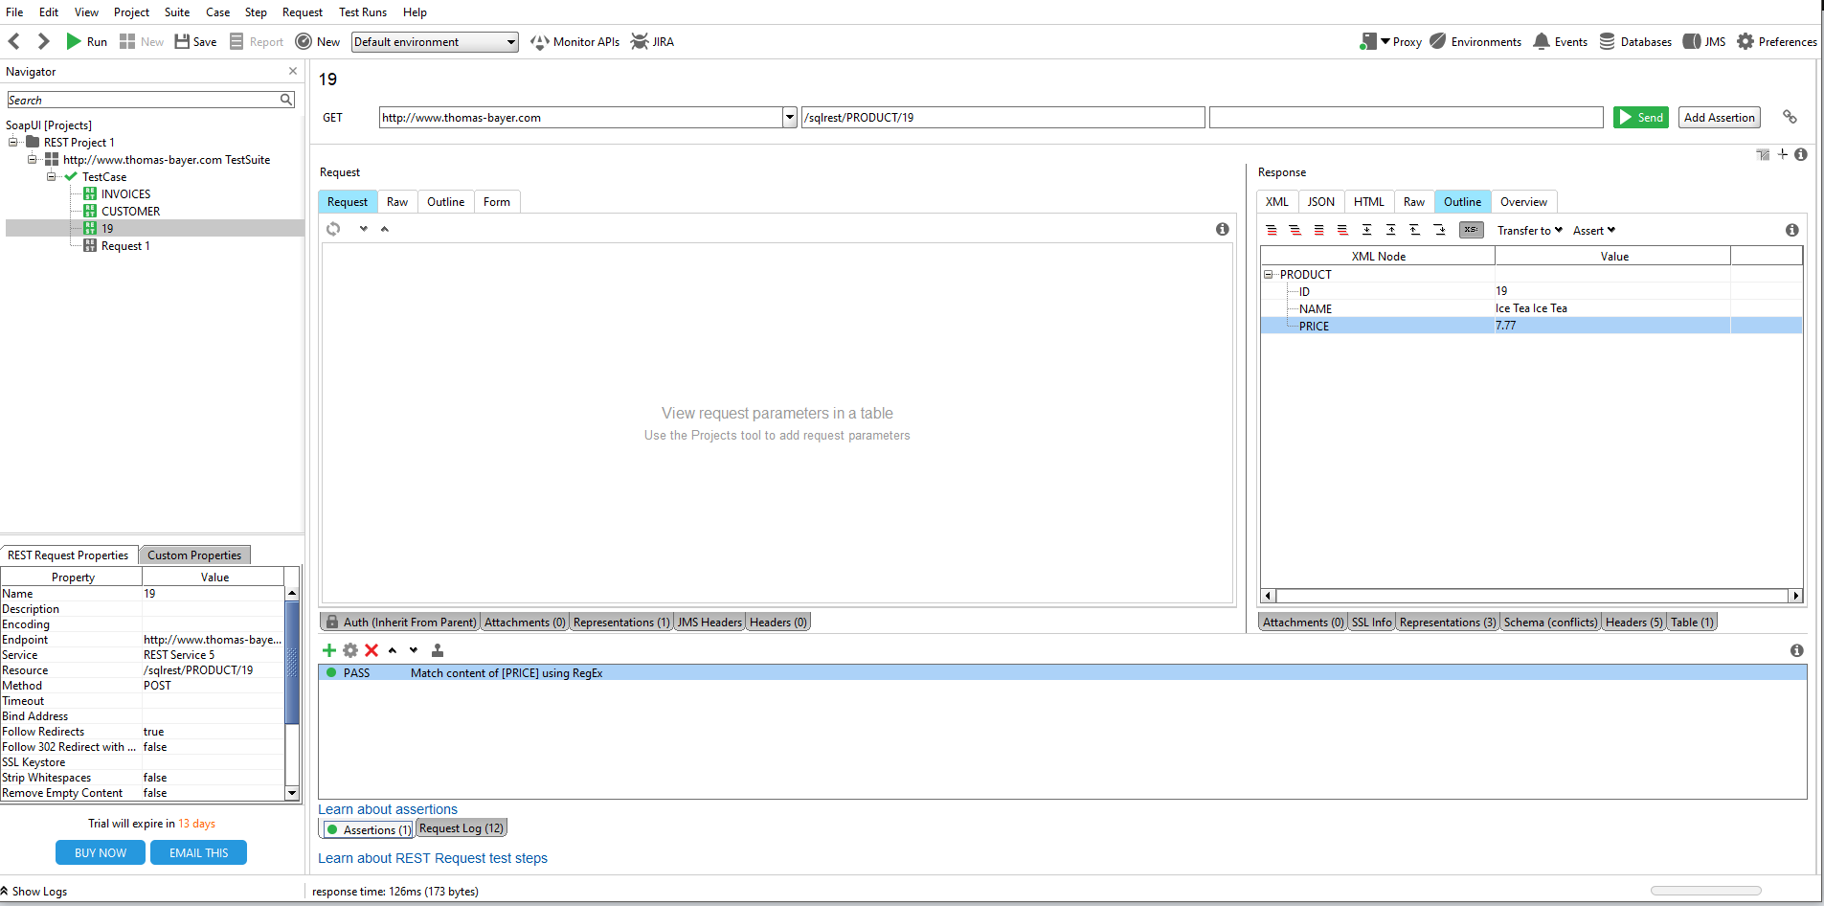

* Check that the server returns "200 OK" after the page has been updated

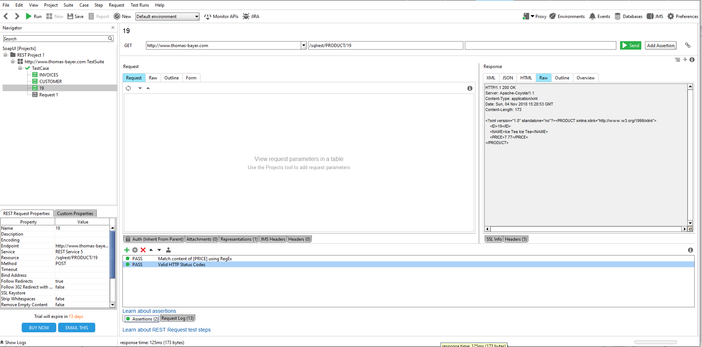

* Check that the page should contains the "ID" and "NAME" fields after the page has been updated

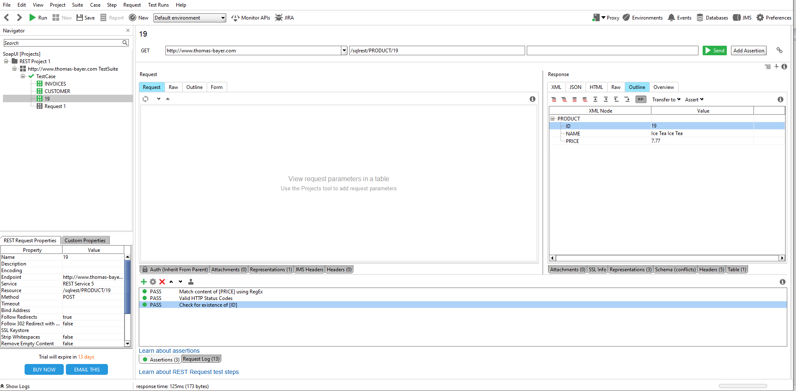

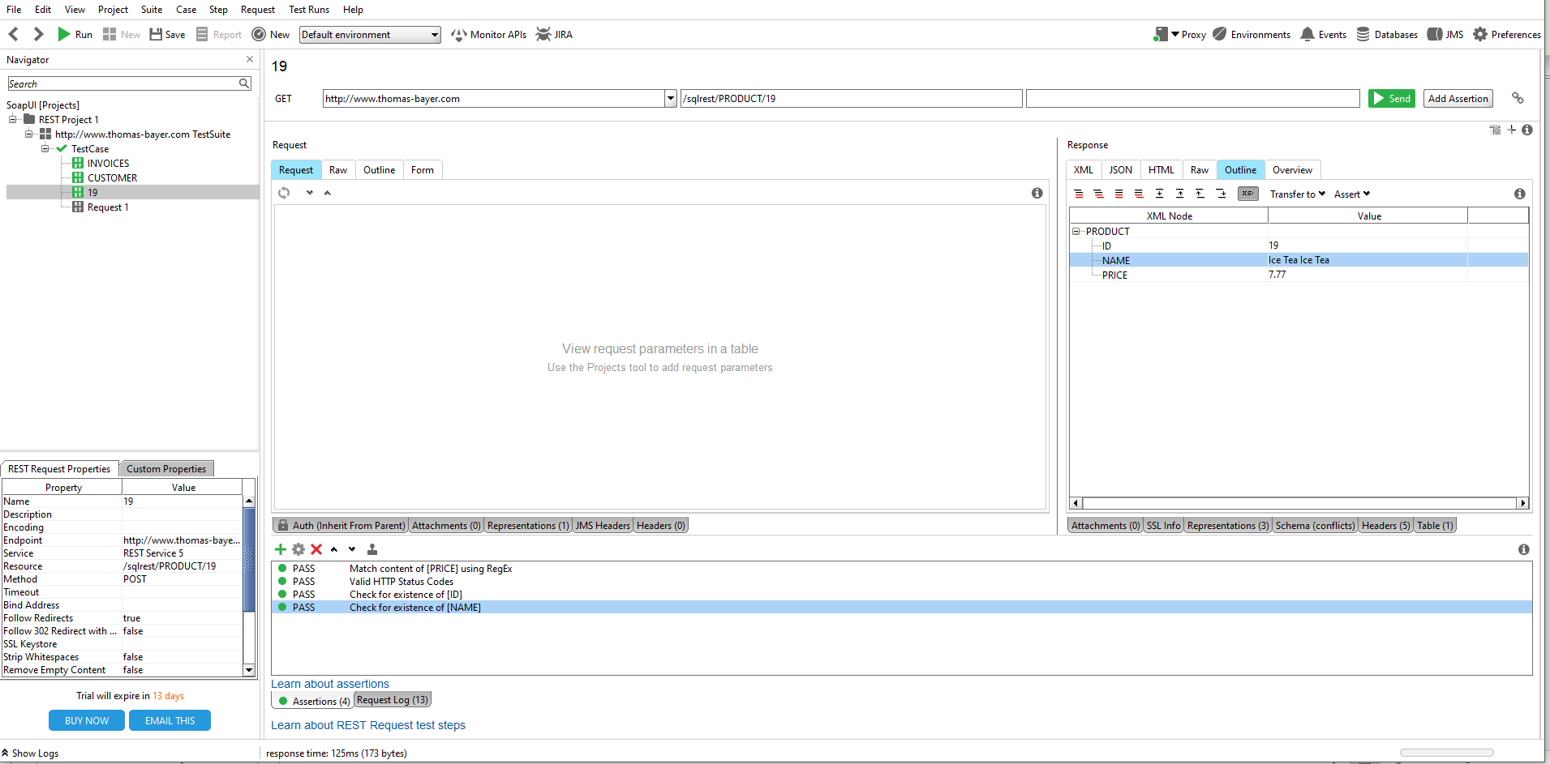

6.1 PUT request for PRODUCT page

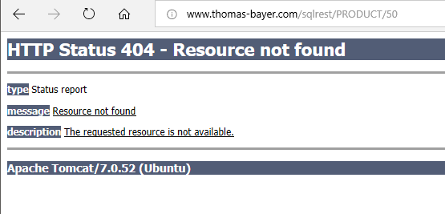

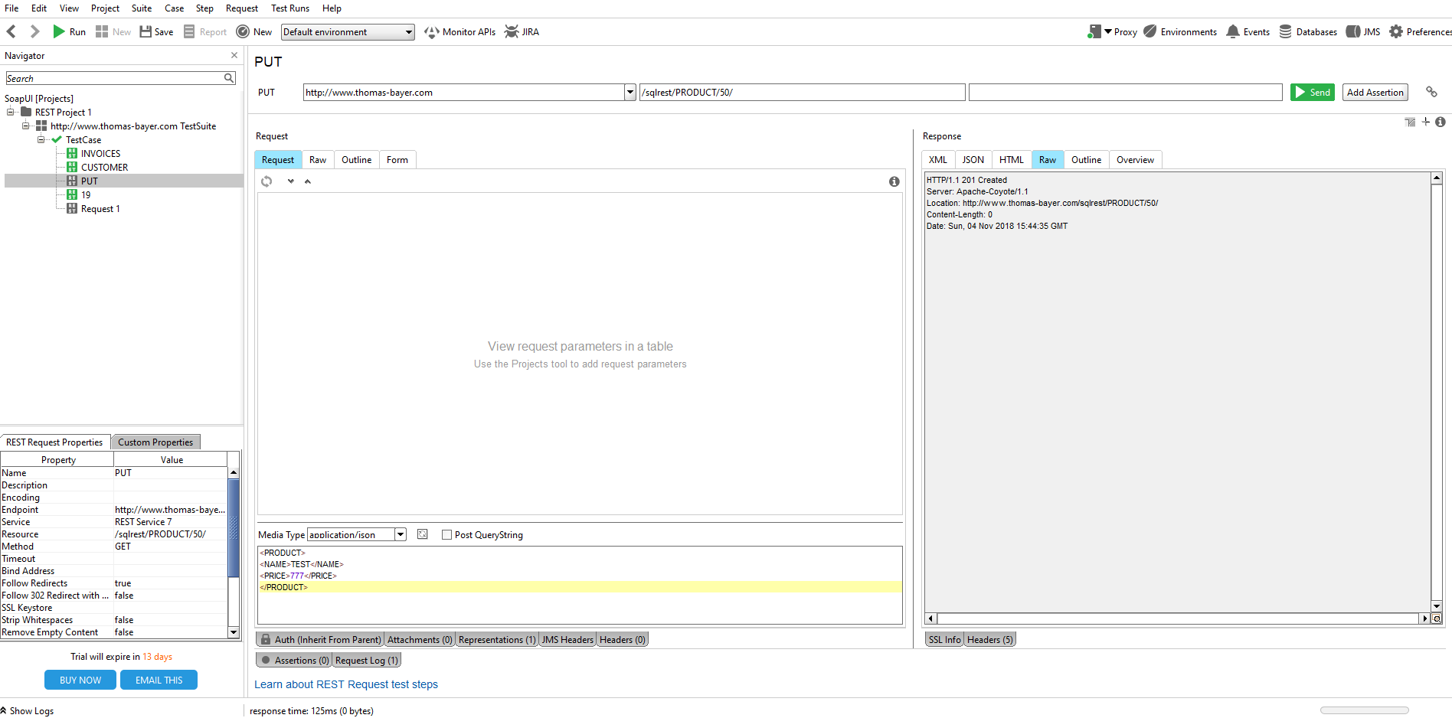

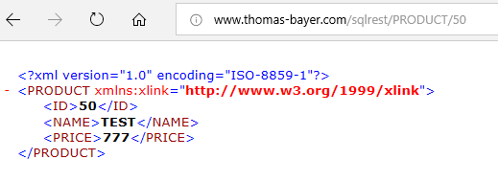

6.2 Create 3 assertions for PRODUCT page

* Check that the server returns "200 OK" after the page has been updated

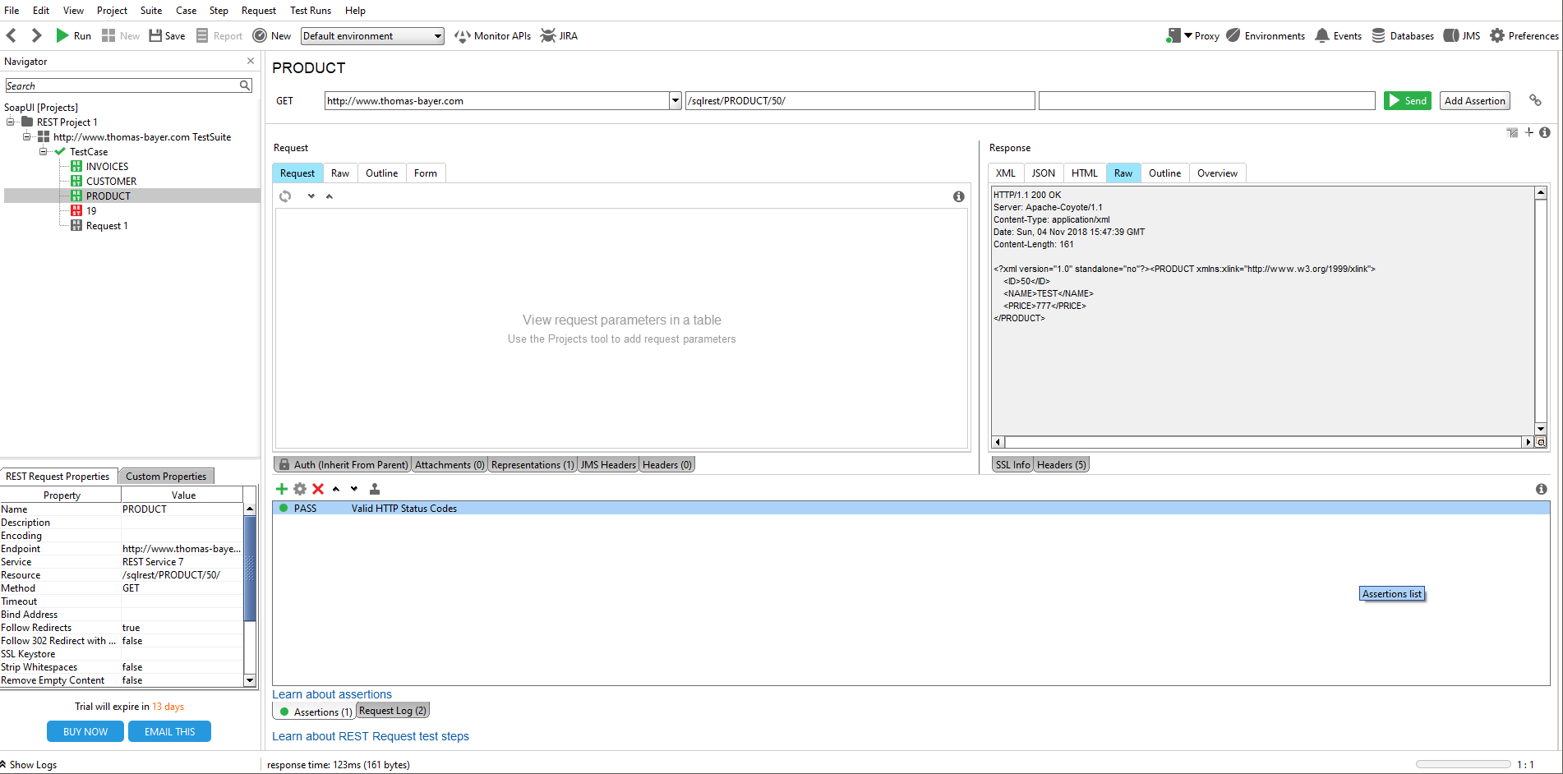

* Check that the page should contains the "ID" field after the page has been updated

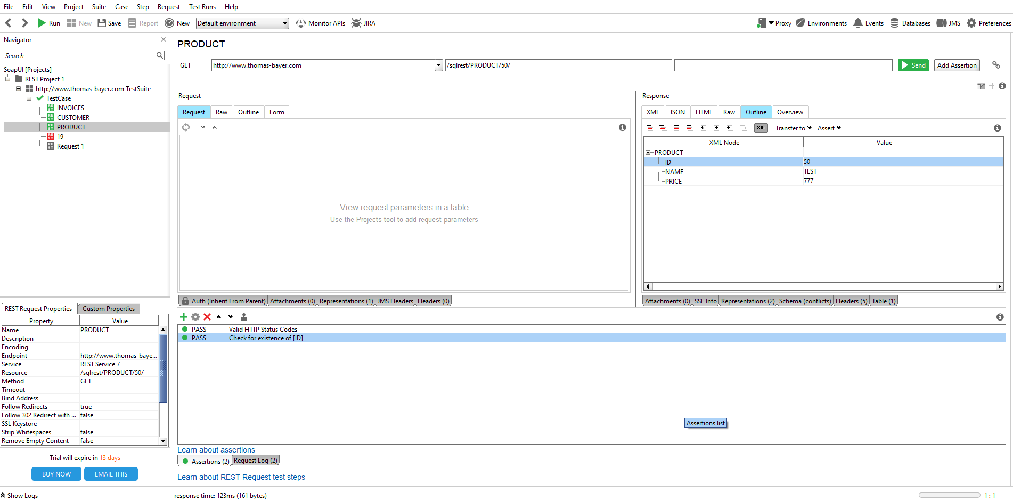

* Check that the entered price value in the put request displays correctly

